 

**SAVITRIBAI PHULE PUNE UNIVERSITY**

The Mini Project Based On

## Study in details Cloud seeds automates IAAS using SDN and high performance network from Juniper SDN Framework

### Submitted By:

Arya Santosh Patil Seat No: B400260139

### Under Guidance of:

Prof. S. K. Chougule

In partial fulfillment of Laboratory Practice-VI (410256)

### DEPARTMENT OF COMPUTER ENGINEERING) SAVITRIBAI PHULE PUNE UNIVERSITY 2024-25

***CERTIFICATE***

This is to certify that the Mini Project based on,

## Study in details Cloud seeds automates IAAS using SDN and high performance network from Juniper SDN Framework

has been successfully completed by,

Name: Arya Santosh Patil Exam seat number: B400260139

Towards the partial fulfilment of the Fourth Year of Computer Engineering as awarded by the Savitribai Phule Pune University, at PDEA’s College of Engineering, Manjari Bk,” Hadapsar, Pune 412307, during the academic year 2024-25.

Prof.S.K.Chougule Dr. M. P. Borawake

**Guide Name H.O.D**

# Acknowledgement

My first and for most acknowledgment is to my supervisor and guide Prof.S.K. Chougule. During the long journey of this study, she supported me in every aspect. She was the one who helped and motivated me to proposer search in this field and inspired me with her enthusiasm on research, her experience, and her lively character.

I express true sense of gratitude to my guide Prof.S.K.Chougule. for her perfect valuable guidance, all the time support and encouragement that he gave me.

I would also like to thanks our head of department Dr. M. P. Borawake and Principal Dr. R. V. Patil and management inspiring me and providing all lab and other facilities, which made this mini project very convenient.

I thankful to all those who rendered their valuable help for successful completion on Internship presentation.

Name: Arya Santosh Patil

|  |  |  |
| --- | --- | --- |
| Sr No. | Contents | Page No. |
| 1. | Abstract | 1 |
| 2. | Introduction | 2 |
| 3. | Objectives | 3 |
| 4. | System Specification | 4 |
| 5. | Methodology | 5 |
| 6. | Sample Code | 7 |
| 7. | Future Scope | 9 |
| 8. | Conclusion | 10 |
| 9. | Reference | 15 |

This experiment aims to investigate the use of Software-Defined Networking (SDN) and a high-performance network based on Juniper SDN Framework to automate Infrastructure as a Service (IAAS) provisioning in cloud environments. The study explores the potential benefits of leveraging SDN technologies to enhance the agility, scalability, and efficiency of IAAS deployments. The experiment involves designing and implementing a proof-of-concept system that combines SDN with Juniper SDN Framework to automate IAAS provisioning processes and evaluate its performance compared to traditional approaches.

Infrastructure as a Service (IAAS) has revolutionized the way organizations manage their IT infrastructure by providing on-demand access to virtualized computing resources. However, manual configuration and management of IAAS platforms can be time-consuming, error-prone, and lack scalability. SDN offers a promising approach to automate IAAS provisioning by decoupling the control and data planes, enabling centralized network management and programmability. This experiment aims to explore the potential of SDN and Juniper SDN Framework in automating IAAS deployments. Cloud Seeds is a comprehensive framework that automates Infrastructure as a Service (IAAS) provisioning using Software-Defined Networking (SDN) and the high-performance network capabilities of the Juniper SDN Framework. This section provides a detailed description of the Cloud Seeds framework, including its architecture, components, and the automation workflow involved in IAAS provisioning.

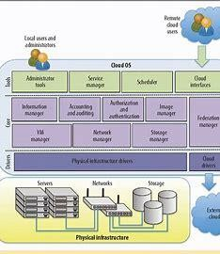

This experiment aims to investigate the use of Software-Defined Networking (SDN) and a high- performance network based on Juniper SDN Framework to automate Infrastructure as a Service (IAAS) provisioning in cloud environments. The study explores the potential benefits of leveraging SDN technologies to enhance the agility, scalability, and efficiency of IAAS deployments. The experiment involves designing and implementing a proof-of-concept system that combines SDN with Juniper SDN Framework to automate IAAS provisioning processes and evaluate its performance compared to traditional approaches.

1. Experimental Setup:
   * Setup a testbed environment comprising of physical and virtual network devices.
   * Deploy Juniper SDN Framework to enable network programmability and automation.
2. IAAS Provisioning Automation:
   * Develop a software application or script to orchestrate IAAS resources using SDN and Juniper SDN Framework.
   * Automate the provisioning, scaling, and teardown of virtual machines, storage, and networking components.
3. Performance Evaluation:
   * Measure the performance of the IAAS automation system in terms of provisioning time, resource utilization, and scalability.
   * Compare the results with traditional IAAS provisioning methods to assess the benefits of SDN and Juniper SDN Framework.
4. Analysis and Discussion:
   * Analyze the experimental results and identify the advantages and limitations of the proposed automation system.
   * Discuss the potential impact of SDN-based IAAS automation on cloud deployments

Cloud Seeds Architecture: The Cloud Seeds architecture a. IAAS Orchestrator: The IAAS Orchestrator is the central component responsible for managing and orchestrating the IAAS provisioning process. It communicates with the SDN controllers and the Juniper SDN Framework to automate the configuration of virtual machines (VMs), storage, and networking resources.

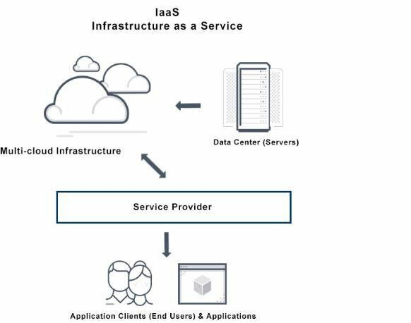

b. SDN Controllers: SDN controllers serve as the control plane in the Cloud Seeds framework. They provide a centralized management interface for configuring and controlling the network infrastructure. The controllers interact with the IAAS Orchestrator to receive provisioning requests and translate them into appropriate network configuration instructions.

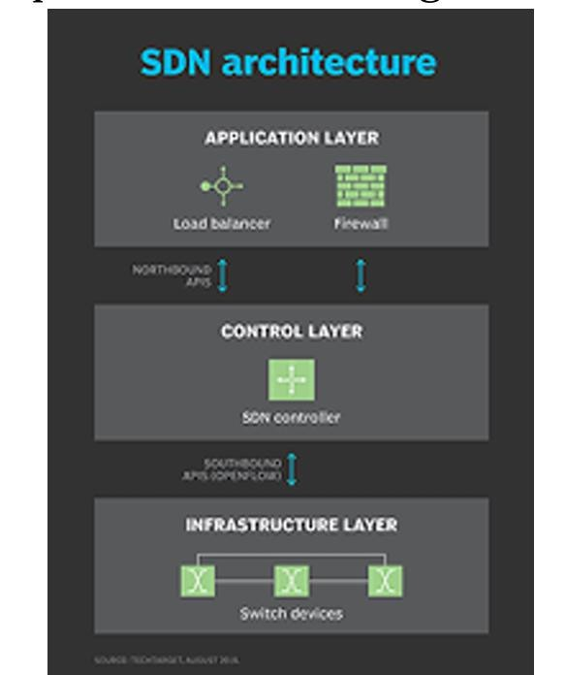

c. Juniper SDN Framework: Juniper SDN Framework is a high-performance networking solution that complements the Cloud Seeds framework. It offers advanced network capabilities, including programmability, policy-based routing, and traffic optimization. Juniper SDN Framework seamlessly integrates with the Cloud Seeds system, providing a robust and efficient networking infrastructure for IAAS deployments.

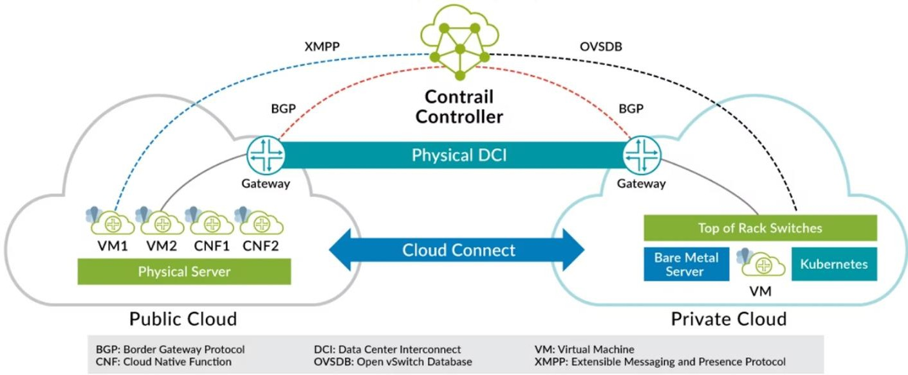

One of the key benefits of the Juniper SDN framework is its ability to virtualize the network infrastructure. By abstracting the underlying physical network, it enables the creation of virtual networks that can be provisioned and configured on-demand. This virtualization brings significant flexibility and efficiency, allowing organizations to quickly adapt to changing business requirements and optimize resource utilization. Overall, the Juniper SDN framework empowers organizations to build agile, scalable, and intelligent networks. It enables them to simplify network management, automate routine tasks, and accelerate service delivery. With its emphasis on openness, flexibility, and virtualization, the Juniper SDN framework is well-positioned to support the evolving demands of modern networking environments.

#### IAAS ACHRITECTURE:

Infrastructure as a Service (IaaS) is a cloud computing service model that provides virtualized computing resources over the internet. In an IaaS layered architecture, the infrastructure is abstracted and provided as a service, allowing users to manage and control their computing resources without the need for physical infrastructure ownership. The IaaS layered architecture consists of the following layers:

**Physical Layer:** At the bottom of the IaaS layered architecture is the physical layer, which comprises the actual physical infrastructure, including servers, storage devices, networking equipment, and data centers. This layer is responsible for providing the underlying hardware resources required to deliver the IaaS services.

**Virtualization Layer:** Above the physical layer is the virtualization layer. This layer utilizes virtualization technologies to abstract the underlying physical resources and create virtual machines (VMs) or virtual instances. Virtualization allows multiple VMs to run concurrently on a single physical server, enabling resource isolation and allocation.

**Infrastructure Management Layer:** The infrastructure management layer sits above the virtualization layer and is responsible for managing and provisioning the virtualized resources. It includes various components and services such as orchestration, automation, resource allocation, and monitoring tools. This layer enables users to control and manage their virtual infrastructure efficiently.

**API Abstraction Layer:** The API (Application Programming Interface) abstraction layer provides an interface between the infrastructure management layer and the user-facing services. It exposes APIs that allow users to interact with the IaaS platform programmatically, enabling automation and integration with other systems. The API abstraction layer facilitates provisioning, scaling, monitoring, and management of the infrastructure resources through API calls.

**User-Facing Services Layer:** At the top of the IaaS layered architecture is the user-facing services layer. This layer includes various services that are exposed to users for managing and utilizing the infrastructure resources.

These services typically include virtual machine management, storage management, networking services, load balancers, security services, and other ancillary services. Users can provision, configure, monitor, and scale their virtual infrastructure using these services through user interfaces or APIs.

#### Algorithm & Implementation:

Algorithm:

1. Initialize IAAS Environment: - Set up a cloud environment using an open source IAAS platform like OpenStack or Apache CloudStack. - Deploy virtualization technologies such as KVM or VMware to manage virtual machines.
2. Integrate Juniper SDN Framework: - Install and configure the Juniper SDN Framework, including SDN controllers and switches. - Establish communication between the IAAS platform and the SDN controller.
3. Automate Resource Provisioning: - Develop a resource allocation algorithm that determines the number of virtual machines and their configurations based on user demand. - Implement the algorithm using the Juniper SDN Framework's APIs to dynamically allocate resources.
4. Implement SDN-based Network Management: - Utilize the Juniper SDN Framework to automate network configuration tasks, including virtual network creation, subnet allocation, and security group setup.

- Implement SDN applications for traffic engineering, load balancing, and QoS provisioning using Juniper SDN APIs.

1. Performance Evaluation: - Measure performance metrics such as response 9 time, network throughput, and resource utilization in the automated IAAS environment. - Compare these metrics with traditional manual provisioning approaches to evaluate the benefits of automation and SDN integration. Implementation Steps:
   1. Set up the IAAS environment: - Install and configure the chosen IAAS platform (e.g., OpenStack) on dedicated servers. - Configure networking components, including switches and routers, for connectivity between the IAAS platform and SDN components.
   2. Deploy Juniper SDN Framework: - Install and configure the Juniper SDN controller and switches, following the documentation provided by Juniper Networks. - Establish communication channels and APIs between the IAAS platform and the Juniper SDN controller.
   3. Develop Resource Provisioning Algorithm: - Design an algorithm that takes into account user demand, resource availability, and scaling triggers to determine optimal resource allocation. - Implement the algorithm using programming languages and APIs compatible with the Juniper SDN Framework.
   4. Automate Network Management: - Utilize Juniper SDN APIs to automate network configuration tasks, such as creating virtual networks, setting up subnets, and applying security policies. - Develop SDN applications using Juniper APIs

to handle traffic engineering, load balancing, and QoS provisioning based on network conditions and policies.

* 1. Conduct Performance Evaluation: - Design a set of performance tests and benchmarks to measure response time, network throughput, and resource utilization in the automated IAAS environment. - Implement the performance evaluation framework using appropriate tools and monitoring systems. - Run the tests and analyze the collected data to evaluate the effectiveness of the automation and SDN integration in improving IAAS performance Automation **Workflow:**

The automation workflow in Cloud Seeds involves the following steps:

* + 1. IAAS Provisioning Request: A user or application submits an IAAS provisioning request to the Cloud Seeds framework. The request specifies the required VMs, storage, and networking configurations.
    2. Request Processing: The IAAS Orchestrator receives the provisioning request and analyzes its requirements. It determines the appropriate network configuration based on the desired IAAS setup.
    3. SDN Controller Communication: The IAAS Orchestrator communicates with the SDN controllers to translate the IAAS provisioning request into network configuration instructions. The SDN controllers leverage the programmability of Juniper SDN Framework to dynamically configure the network resources.
    4. Network Configuration: The SDN controllers, using the Juniper SDN Framework, configure the networking infrastructure according to the provisioning request. This includes setting up virtual networks, defining routing policies, and implementing quality of service (QoS) measures.
    5. Virtual Resource Provisioning: The IAAS Orchestrator interacts with the virtualization infrastructure, such as the hypervisors, to provision the required VMs and storage resources. It ensures that the VMs are deployed on the appropriate hosts and that the storage volumes are allocated correctly.
    6. Completion and User Access: Once the provisioning process is complete **Benefits and Advantages:** Cloud Seeds offers several benefits and advantages for IAAS provisioning:

1. **Automation and Agility:** By leveraging SDN and Juniper SDN Framework, Cloud Seeds automates and accelerates the IAAS provisioning process, reducing

manual effort and time. It enables rapid deployment of virtual resources and facilitates the dynamic scaling of IAAS environments. b. Enhanced Performance and Scalability: The high-performance network capabilities of Juniper SDN Framework ensure optimized data transfer, low latency, and efficient traffic routing. This results in improved performance and scalability of IAAS deployments, allowing for seamless handling of increasing workloads.

1. **Centralized Management and Control:** The centralized management interface provided by SDN controllers and the IAAS Orchestrator allows for unified control and monitoring of the IAAS infrastructure. It simplifies administration tasks, enhances network visibility, and enables effective resource utilization. d. Flexibility and Customization: Cloud Seeds offers flexibility and customization options through the programmability of SDN and the advanced capabilities of Juniper SDN Framework. It enables the definition and enforcement of policies, QoS rules, and network configurations tailored to specific IAAS requirements. Limitations and Challenges: While Cloud Seeds provides significant benefits, some limitations and challenges should be considered: a. Learning Curve: Adopting SDN and Juniper SDN Framework may require a learning curve for administrators and operators who are unfamiliar with these technologies. Training and expertise are essential to effectively utilize the framework's capabilities.
2. **Integration Complexity:** Integrating the Cloud Seeds framework with existing IAAS deployments or legacy systems may pose challenges. Ensuring compatibility, data migration, and coexistence with conventional networking components may require careful planning and implementation. c. Security and Compliance: As with any IAAS environment, ensuring robust security measures and compliance with industry standards and regulations is crucial. Cloud Seeds should incorporate appropriate security controls, encryption, access management, and monitoring mechanisms to protect IAAS resources and user data. d. Scalability and Performance Testing: It is important to conduct thorough testing and performance evaluations to assess the scalability and performance of the Cloud Seeds framework under various workload scenarios.
3. **Enhanced Predictive Modeling:**
   * Deep Learning Techniques: Explore the use of deep learning models, such as recurrent neural networks (RNNs) and long short-term memory (LSTM) networks, which are well-suited for time series forecasting.
   * Ensemble Methods: Investigate ensemble learning techniques (e.g., random forests, gradient boosting) to improve prediction accuracy by combining multiple models.
4. **Broader Feature Set:**
   * Incorporate Alternative Data: Integrate alternative datasets such as social media sentiment, news sentiment analysis, and macroeconomic indicators to enhance the predictive power of models.
   * Technical Indicators: Explore a wider range of technical indicators, including Bollinger Bands, RSI, and MACD, to capture additional market dynamics.
5. **Real-Time Analytics:**
   * Live Market Data Integration: Develop systems that can analyze and predict stock prices in real-time using streaming data, providing instant insights for traders and investors.
   * Automated Trading Systems: Build automated trading algorithms based on predictive models to capitalize on market opportunities in real-time.
6. **Risk Management Frameworks:**
   * Volatility and Risk Assessment: Create robust frameworks for assessing and managing investment risks based on historical volatility and predictive insights.
   * Portfolio Optimization: Develop models that optimize asset allocation in investment portfolios based on predicted stock returns and risk profiles.
7. **Comparative Studies:**
   * Cross-Market Analysis: Conduct comparative studies between the Indian stock market and other global markets to understand the unique factors affecting each market’s behavior.
   * Sector-Specific Analysis: Explore predictive modeling specific to various sectors (e.g., technology, finance, healthcare) to identify sector-specific trends and behaviors.
8. **User-Friendly Tools:**
   * Visualization Dashboards: Create interactive dashboards for investors to visualize stock trends, forecasts, and key indicators, enhancing accessibility and decision-making.
   * Mobile Applications: Develop mobile applications that provide users with real-time insights and predictions, catering to retail investors.
9. **Research and Education:**
   * Academic Contributions: Contribute to the academic literature on financial markets by publishing findings, methodologies, and new predictive models.
   * Educational Resources: Develop courses or workshops aimed at teaching investors and students how to analyze stock data and utilize predictive modeling techniques effectively.
10. **Sustainability and Ethical Investing:**
    * ESG Factors Integration: Research the impact of Environmental, Social, and Governance (ESG) factors on stock performance and integrate these metrics into predictive models.
    * Responsible Investing: Explore how predictive analytics can guide investors toward more responsible and sustainable investment choices.

This study on the analysis and prediction of stock price movements in the Indian market from 2000 to 2020 highlights the intricate dynamics of financial markets and the potential of data-driven approaches in enhancing investment strategies. Through a comprehensive examination of historical stock data, the research identifies key trends, correlations, and influential factors affecting stock prices. The application of various statistical and machine learning techniques demonstrates the feasibility of creating predictive models that can inform investment decisions.

The results indicate that while traditional methods, such as linear regression, provide a solid foundation for understanding market behavior, there is significant scope for improvement through the incorporation of advanced algorithms and additional features. The exploration of deep learning models and alternative data sources presents exciting opportunities for more accurate forecasting and real-time analytics.

Moreover, this research underscores the importance of integrating insights gained from historical data into practical applications, such as automated trading systems and risk management frameworks. The findings not only contribute to academic knowledge but also offer valuable implications for investors and financial analysts seeking to navigate the complexities of the stock market.

Looking ahead, the future of stock price prediction holds immense potential for innovation and advancement. By embracing new technologies and methodologies, the financial industry can better equip itself to adapt to market changes, enhance decision-making, and ultimately achieve more sustainable investment outcomes. This study serves as a foundational step toward a deeper understanding of the Indian stock market, encouraging further research and development in this critical area of finance.

* + - [https://www.github.com](https://www.github.com/)
    - <https://chat.openai.com/>
    - <https://www/w3schools.com>
    - [Stock Market Prediction Using Machine Learning (2024) (analyticsvidhya.com)](https://www.analyticsvidhya.com/blog/2021/10/machine-learning-for-stock-market-prediction-with-step-by-step-implementation/)